Technical Datasheet Input / Output Modules with Modbus RTU Protocol with RS485 Interface

The IO modules communicate via RS485. The port can drive distances up to max 700 meters without the use of any repeater (this feature however also depends on the signal strength of the Modbus Master Device).
The RS485 Digital IO module is sturdy, low power usage and easy to use.

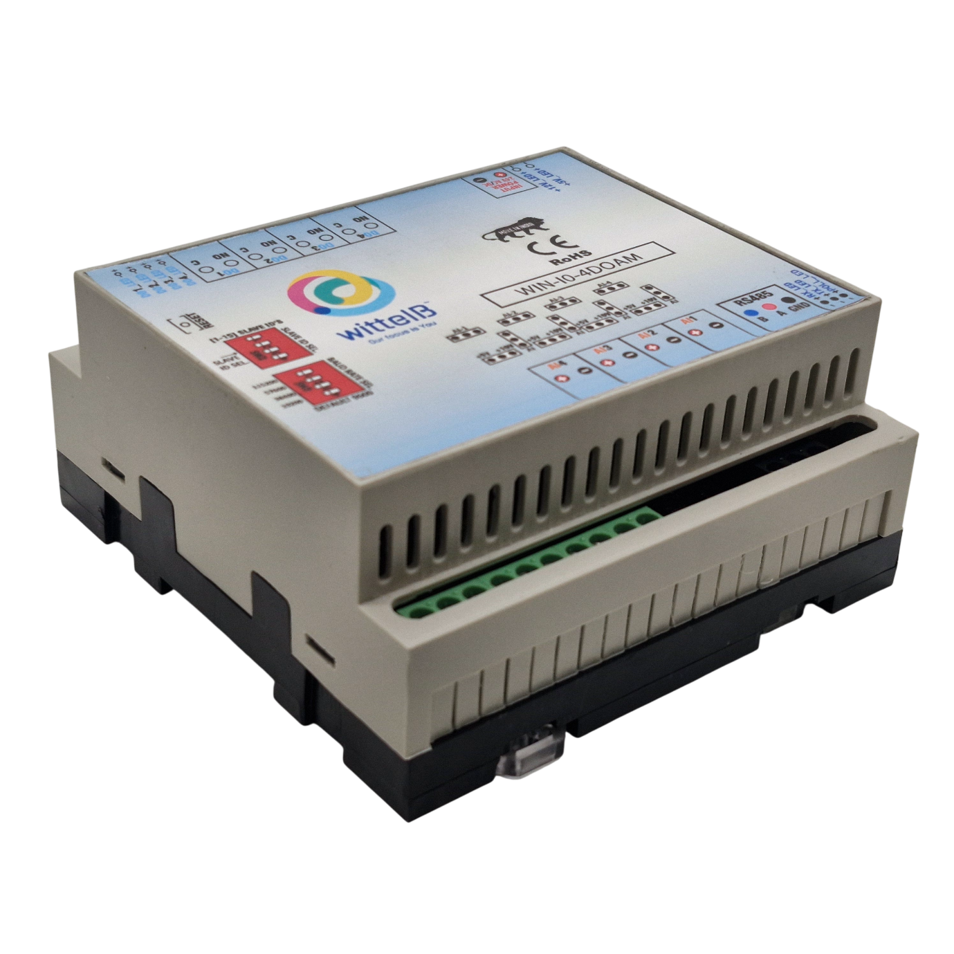
4 Port DO + 4 AI Module: -
The IO modules are mounted on DIN rail mountable casing and with exposed connectors and LED indicators. The DIP switch for Slave ID and Baud rate are placed inside the enclosure.
The design of the modules incorporates ‘resettable Fuses’ to safeguard against sudden High Voltage spikes. the board also has ‘reverse polarity’ protection both for input and power connector.
the communication port also has signal isolation and additional jumper for ‘end of line’120 ohms termination resistance which may or may not be used.

Specifications
General –
I/O Connectors 12 Pin 5.08 mm pitch pluggable screw Terminal Block, 2 Pin 5.08 mm pitch pluggable screw terminals.
Dimensions 110 mm L x 110 mm B x 50 mm H
Power Input Power – 12 - 24 VDC or 24 V AC/DC
Typical – 12V DC @ 120mA
Operating Temperature 0 – 60° C (32 ~ 140°F)
Storage Temperature -20 - 70° C (-4 ~ 158°F)
Storage Humidity 5 ~ 95 % RH, non – Condensing

Certifications

Without load: ~69 mA @12 VDC
With full load: ~300 mA @ 12 VDC

DO with Relay Output –
Channels 4
Contact Form 1A, 1C
Contact Material Ag Alloy
Contact Capacity 10A @ 240VAC, 10A @ 28VDC
Coil Voltage 5 – 48 VDC
Coil Power 0.36 W
Insulation Resistance 250MΩ
Electrical Life 1 x 10^5
Mechanical Life 1 x 10^7
Operating Time 7 msec, Max 15 msec
Release Time 2 msec, Max 6 msec

AI Inputs –
Channels 4
Input Signal 4 – 20 mA / 0 – 10VDC / 0 – 5VDC (Jumper selectable)
Accuracy ± 2% Full scale
Input Resolution 10 bits / 12 bits (Optional)
Isolation Optically Isolated
External Loop Voltage + 12 VDC min
AI input impedance 120Ω
Additional Features: -
All inputs and communication ports isolated
Input power reverse polarity safety
ESD Safety IEC 61000-4-2, ± 30KV contact, ± 30KV air
EFT IEC 61000-4-4, 50A (5/50ms)
750V isolation.
CRC Error check.
No configuration needed on the IO board

DIP SETTING – For Manual Switch Setup

Configuration Settings: -
Communication Speed 9600 – 115200 (DIP SW selectable)
Data Bits 8
Parity None
Stop bit 1
CRC Yes
Slave ID Configurable with DIP Switch
Function code DO 0x05 and 0x0F (5 Single coil & 15 multiple coil)
DO Register Address 0,1,2,3.
Function Code AI 0x03 Read Holding Registers
AI Register Address 10 Bit – 1,2,3,4 / 12 Bit – 5,6,7,8.

Note: -
For MODBUS communications, a shielded and twisted pair cable is used. One example of such cable is Belden 3105A.
Recommended Cable Electrical Characteristics: -
22 AWG Cable Shielded and twisted pair should be used.
Tinned Copper Recommended
Nominal Conductor DCR 14.7 ohm / 1000 ft
Nominal Capacitance 11 pf / feet (conductor to conductor)
High Frequency Non-Insertion Loss 0.5db / 100ft

ID | Function  Description | Register  Description | Modbus Function Code | Protocol | Data  Type
1 | DO 1 | 00001 | 0X05,0X0F | RS485 | 1 Bit Boolean
2 | DO 2 | 00002 | 0X05,0X0F | RS485 | 1 Bit Boolean
3 | DO 3 | 00003 | 0X05,0X0F | RS485 | 1 Bit Boolean
4 | DO 4 | 00004 | 0X05,0X0F | RS485 | 1 Bit Boolean
5 | AI 1 – 10 Bit | 40002 | 0X03 | RS485 | 16 Bit Unsigned int
6 | AI 2 – 10 Bit | 40003 | 0X03 | RS485 | 16 Bit Unsigned int
7 | AI 3 – 10 Bit | 40004 | 0X03 | RS485 | 16 Bit Unsigned int
8 | AI 4 – 10 Bit | 40005 | 0X03 | RS485 | 16 Bit Unsigned int
9 | AI – 1 12 Bit | 40006 | 0x03 | RS485 | 16 Bit Unsigned int
10 | AI – 2 12 Bit | 40007 | 0x03 | RS485 | 16 Bit Unsigned int
11 | AI – 3 12 Bit | 40008 | 0x03 | RS485 | 16 Bit Unsigned int
12 | AI – 4 12 Bit | 40009 | 0x03 | RS485 | 16 Bit Unsigned int

BAUD RATE DESCRIPTION:

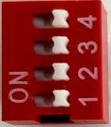

L
SB

M
SB

  - For Baud rate Selection, DIP SW is used as per the diagram.
  - Pulling up the switch will make Baud rate active.
  - If no selection is made 9600 will be default Baud rate.
  - When u change the Baud rate in the Module power ‘ON” condition, press the reset button to get Change to affect.

SLAVE ID DESCRIPTION
MSB
LSB
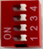

For Slave ID Selection SW is used to Set The SLAVE ID .
For Slave ID DIP Switch LSB is “1” follow through “4” is MSB.
Slave ID Confirmed through below Device ID table .
IF Eg. Slave ID 1 is Needed to be selected Switch number 1 should pulled up other three should be selected down side. So”1 0 0 0” will be selected as Slave ID 1.

Slave ID | DIP SWITCH |  |  |  | OUTPUT (Binary) | OUTPUT (Decimal)
 | 1 | 2 | 3 | 4
0 | OFF(0) | OFF(0) | OFF(0) | OFF(0) | 0 0 0 1 | 1
1 | ON(1) | OFF(0) | OFF(0) | OFF(0) | 0 0 0 1 | 1
2 | OFF(0) | ON(1) | OFF(0) | OFF(0) | 0 0 1 0 | 2
3 | ON(1) | ON(1) | OFF(0) | OFF(0) | 0 0 1 1 | 3
4 | OFF(0) | OFF(0) | ON(1) | OFF(0) | 0 1 0 0 | 4
5 | ON(1) | OFF(0) | ON(1) | OFF(0) | 0 1 0 1 | 5
6 | OFF(0) | ON(1) | ON(1) | OFF(0) | 0 1 1 0 | 6
7 | ON(1) | ON(1) | ON(1) | OFF(0) | 0 1 1 1 | 7
8 | OFF(0) | OFF(0) | OFF(0) | ON(1) | 1 0 0 0 | 8
9 | ON(1) | OFF(0) | OFF(0) | ON(1) | 1 0 0 1 | 9
10 | OFF(0) | ON(1) | OFF(0) | ON(1) | 1 0 1 0 | 10
11 | ON(1) | ON(1) | OFF(0) | ON(1) | 1 0 1 1 | 11
12 | OFF(0) | OFF(0) | ON(1) | ON(1) | 1 1 0 0 | 12
13 | ON(1) | OFF(0) | ON(1) | ON(1) | 1 1 0 1 | 13
14 | OFF(0) | ON(1) | ON(1) | ON(1) | 1 1 1 0 | 14
15 | ON(1) | ON(1) | ON(1) | ON(1) | 1 1 1 1 | 15

SOFT SETTING – For Modbus / Software Setup
Configuration Settings: -
Communication Speed 9600 – 115200 (DIP SW selectable)
Data Bits 8
Parity None
Stop bit 1
CRC Yes
Slave ID Soft settings (1-247).
Function code DO 0x05 and 0x0F (5 Single coil & 15 multiple coil)
DO Register Address 0, 1, 2, 3.
Function code DI 0x02 Read Discrete Input
Function Code Soft Serial 0x03 Read Holding Registers
Soft serial Register Address 11, 12, 13, 14, 15, 16, 17, 18.

ID | Function  Description | Register  Description | Modbus Function Code | Protocol | Data  Type
1 | Current Baud Rate | 40011 | 0x03 | RS485 | 16 Bit Unsigned int
2 | New Baud Rate | 40012 | 0x03 | RS485 | 16 Bit Unsigned int
3 | Current SID | 40013 | 0x03 | RS485 | 16 Bit Unsigned int
4 | New SID | 40014 | 0x03 | RS485 | 16 Bit Unsigned int
5 | Current Parity | 40015 | 0x03 | RS485 | 16 Bit Unsigned int
6 | New Parity | 40016 | 0x03 | RS485 | 16 Bit Unsigned int
7 | Current Stop-bit | 40017 | 0x03 | RS485 | 16 Bit Unsigned int
8 | New Stop-bit | 40018 | 0x03 | RS485 | 16 Bit Unsigned int

Note: -
- In register 40015- you will able to see the current parity and you can change it in register 40016
- In register 40017- you will able to see the current stop bit and you can change it in register 40018
- If you want to enter the baud rate 9600/19200/38400/57600/115200etc. Enter it as 960/1920/5760/11520etc.
- After that press the reset button or reboot the system.
- For MODBUS communications, a shielded and twisted pair cable is used. One example of such cable is Belden 3105A

BAUD RATE and SLAVE ID DESCRIPTION:

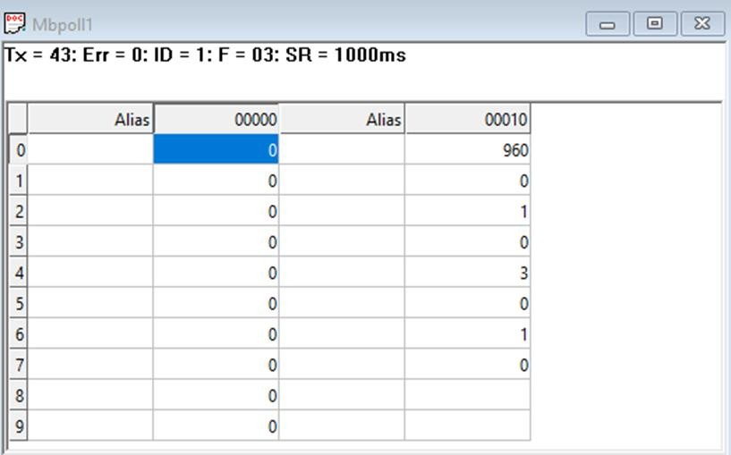

  - As you can see in the image above, the resistor 40011 – 960 represents the present bund rate (9600) of the board and 40013 – 1 represents the present slave id of the board.
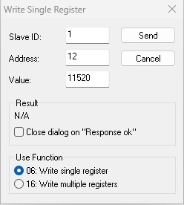
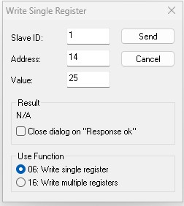
  - To change the baud rate and slave id you have to enter a value on the 40012, resistor for the baud rate and 40014 for the slave id as shown in the image below.

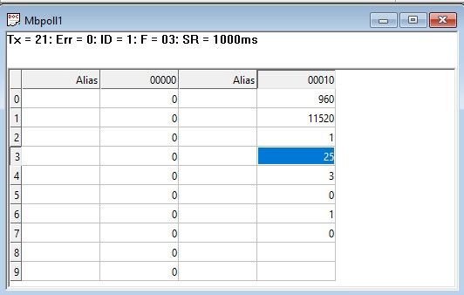
As you can see in the image above I set 115200 baud rate and slave ID 25.

Note:
- When entering baud rate values such as 9600 / 19200 / 38400 / 57600 / 115200, enter them as 960 / 1920 / 3840 / 5760 / 11520, respectively.
- After entering the values, press the reset button or reboot the system.
- Once restarted, you will see the updated values:
- 40011 – 11520 → Baud Rate (115200)
- 40013 – 25 → Slave ID (25)
- You can also change Parity Bit and Stop Bit of the device in the same way.
- Jumper Setting (Hardware Method):
- If you place the jumper, the device will load its default communication settings (default baud rate (9600) and slave ID (1)).
- This is useful when you have many devices with different settings and want a quick way to restore defaults without software changes.
- Relation between Jumper and Reset Button:
The jumper enables the default mode, and the reset button activates it.
- Simply insert the jumper → press reset → the device restarts with factory default settings automatically

AI

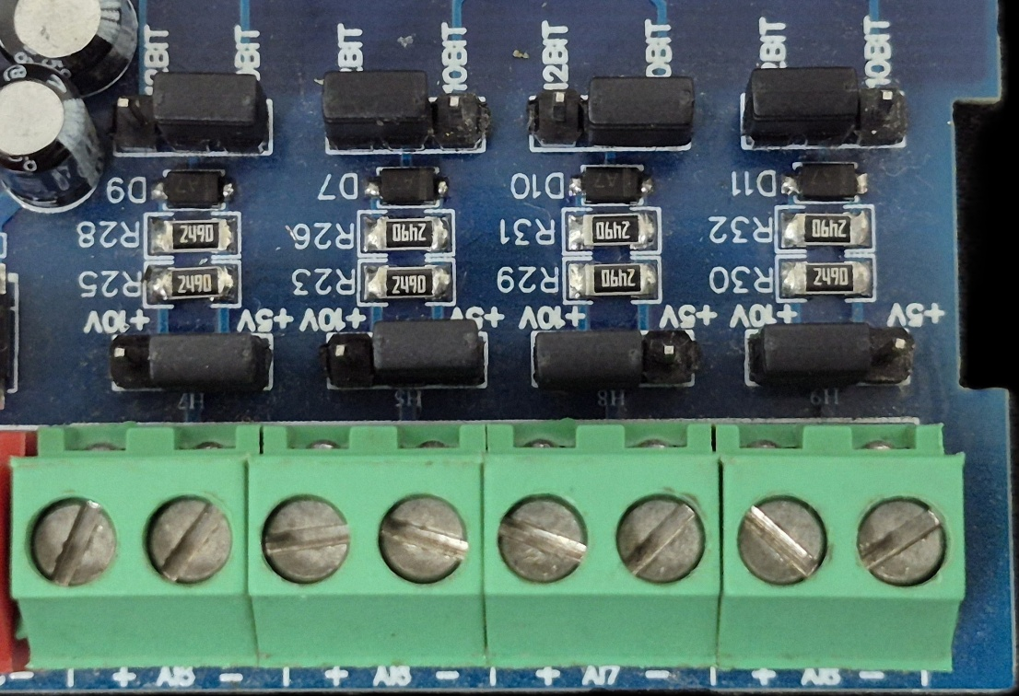
Sensor
Sensor
Sensor
Sensor

- Analog Input (AI) Operation: Each channel provides two terminals: + (Positive) and - (Negative/Common). These are used to read external analog sensor signals.
- Channel Configuration (Visual Guide): Each of the four AI channels features two dedicated jumpers to independently set the voltage range and bit resolution. Refer to the color-coded boxes in the board diagram to configure your desired scenario:
  - Red Box (5V, 10-bit): Set the voltage jumper to +5V and the resolution jumper to 10 BIT.
  - Green Box (5V, 12-bit): Set the voltage jumper to +5V and the resolution jumper to 12 BIT.
  - Blue Box (10V, 10-bit): Set the voltage jumper to +10V and the resolution jumper to 10 BIT.
  - Yellow Box (10V, 12-bit): Set the voltage jumper to +10V and the resolution jumper to 12 BIT.
- Sensor Wiring Connections:
  - The analog sensor's positive signal wire should be connected to the + terminal of the desired channel.
  - The sensor's common or ground wire should be connected to the corresponding - terminal.
- Crucial Setup Recommendation: Always ensure that the voltage jumper setting strictly matches the maximum output range of your connected sensor (either 5V or 10V) to guarantee accurate analog-to-digital conversion and prevent data clipping.

DO

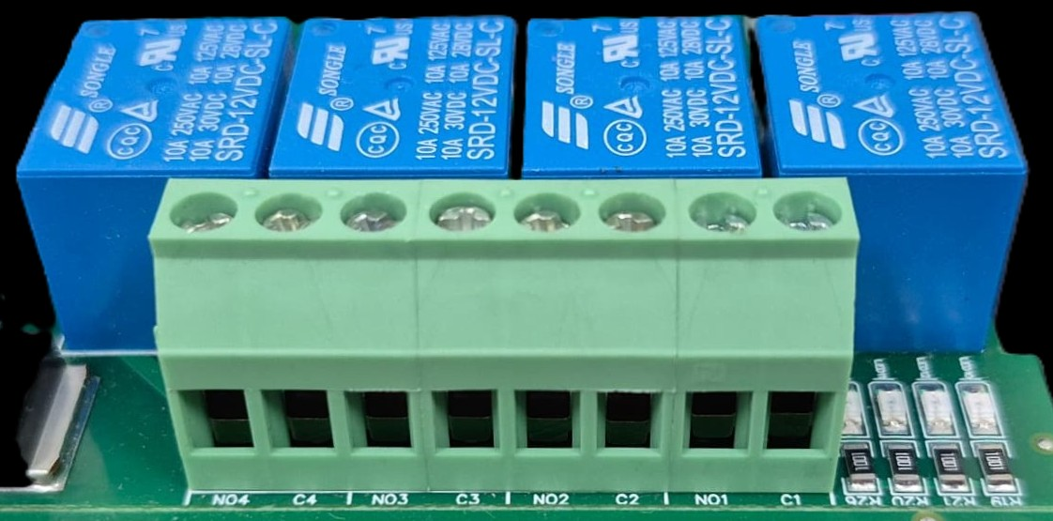





L
O
A
D
N

P
L
O
A
D
N

P
L
O
A
D
N

P
L
O
A
D
N

P

- Digital Output (DO) operation: Each channel provides two terminals: C (Common) and NO (Normally Open). When the relay coil is energized, terminal C is internally connected to NO, allowing current to flow. When the relay is de-energized, the connection between C and NO remains open, and the load stays OFF.
- Load Wiring Connections:
  - AC Load Connection: The AC Live (Phase) wire should be connected to terminal C. The load is connected between terminal NO and Neutral (N).
  - DC Load Connection: The positive supply (+V) should be connected to terminal C. The load is connected between terminal NO and Ground (GND).
- Crucial Safety Recommendation and Rating: It is strongly recommended to switch the Live (Phase) conductor in AC applications to ensure the load is safely de-energized when the relay is off.
Note: Ensure that the connected load does not exceed the relay’s contact rating of 10A @ 250VAC (or 10A @ 125VAC) or 10A @ 30VDC (or 10A @ 28VDC).

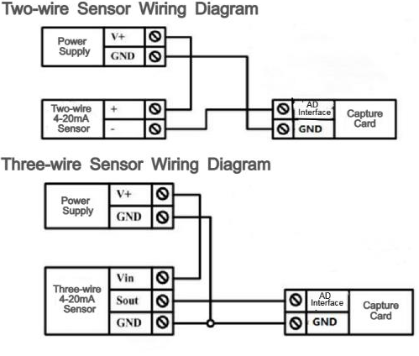
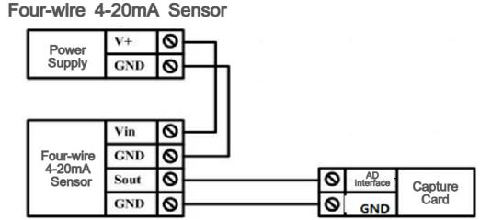

4 3 2 1
DO- NO Contacts

AI4 AI3 AI2 AI1
Analog Input Pins
MSB
LSB
SLAVE ID
Modbus RS485
Input 24 VDC
5V / 10 V
AI Jumper
10 / 12 Bit
AI Jumper

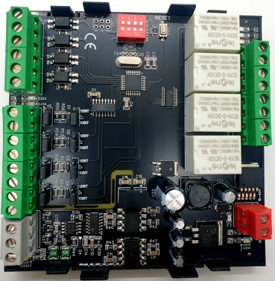

Contact Information
Augmatic Technologies Pvt. Ltd.,
Plot no 6, Shah Industrial Estate II,
Kotambi,
Vadodara – 391510.
Email – Sales@wittelb.com
Support E.: support@wittelb.raiseaticket.com / M.: 9403892805

